# Healthcare Data Analysis App for Helping Patients to Get Proper Treatment at Lower Cost

Abstract

This project involves developing a healthcare analysis app that utilizes data science to identify patient medical history, treatment outcomes, and patterns. The app will provide personalized health advice and treatment plans, enabling patients to compare treatment costs and select doctors based on their small bio. Patients can also upload their prescriptions and receive recommendations for apps that offer certified medication at lower prices. The app will also benefit healthcare professionals by reducing treatment costs and time. It will provide proper medical treatment at a reasonable cost, thus reducing fraud cases related to medical reasons.

Many healthcare providers, including hospitals and medical apps, use Healthcare Analysis for medical tests, purchasing medicine, doctor consultations, and health supplement advice.

Problem Statement

The problem statement is to analyse the medical conditions of patients based on their symptoms and medical history using healthcare analysis. In our country, a large population of patients faces difficulty in finding the right place for their treatment, and many doctors prescribe expensive medications that patients have to buy, impacting their financial condition. Additionally, patients are often targeted by fraudsters who offer quick access to doctors from big hospitals. To address these issues, I am working on a service that will assist patients in finding the appropriate place for treatment, purchasing medications with the same composition but at a lower price, and scheduling appointments with doctors at hospitals to prevent them from falling victim to fraud. This service will help patients reduce their medical expenses.

Business Need Assessment

As we are aware, medical facilities in small towns and villages are often inadequate to provide proper medical treatment for various diseases and trauma conditions. Patients are forced to travel to bigger cities, where they may not know which hospital to go to private hospitals in these cities can be very expensive and often prescribe unnecessary tests and high-cost medication. This can be especially difficult for patients from weaker sections of society, who may have to liquidate their assets to pay for treatment. This system/app can help patients find hospitals that offer similar facilities at lower costs, such as large government hospitals. Additionally, patients can opt for generic medicines with the same composition as high-cost medicines, but at a lower cost.

Target Specification

This service or app aims to assist patients in finding the appropriate medical facilities according to their financial capacity. The government provides several medical treatment schemes for the weaker sections of society, and this app aims to inform patients of such schemes to help them with their treatment expenses. The app also helps them find competent doctors who specialize in the treatment of their specific disease. This will ensure that their treatment starts perfectly with the best facilities available at a lower cost. This will not only save many lives but also bring a small smile to the faces of those who can now afford the correct treatment at a lower cost.

External Search

I used the following sources as references for analyzing the need for a service or app that provides patients with proper treatment and medicine at a lower cost, as well as how big medical services such as Tata1mg and Apolo use techniques to attract patients and enhance medical facilities:

- Health Care Analysis Article

- Patient Optimization Techniques

- How Medical Services/Apps Use These Techniques

- Resource Allocation and Operational Efficiency

- Drug Discovery and Development

- Remote Patient Monitoring.

- AI healthcare breakthroughs.

Benchmarking Alternate Products

Healthcare services giants like Apollo and Tata1mg utilize blend technology to provide accessible medical information, prescription services, and personalized recommendations, thereby enhancing the overall patient experience.

Applicable Patents

1. AI-driven Health Assistant-- Various companies offer personalized medical advice using AI technology. Some of these companies include Your.MD, Suki.AI, Babylon Health, CureMe, Oscar Health, and Welltok. These companies develop their versions of AI-powered HER systems that can analyse patient data for better decision-making, improved healthcare delivery, and treatment recommendations. The EHR systems are offered by healthcare giants such as GE Healthcare, Oracle, Cerner, Allscripts, and Epic.
2. AI-based system that can personalize treatment plans for patients.
3. AI system that detects Alzheimer's disease from brain scans.
4. AI-based system that can detect and prevent healthcare fraud.
5. AI-based system that can personalize cancer treatment plans for patients.

Applicable Regulations

* Data protection and privacy regulations (Patients).
* Govt Regulations for Healthcare Services.
* Drug Control Act.

Applicable Constraints

* **Taking Medical Data from Patients.**
* **Always Updating Data.**
* **Convincing Patients to use Service.**
* **Awareness of the disease symptoms.**
* **Convincing the Patients and Small healthcare units to use the Service**: Small healthcare units are usually the first point of contact for patients seeking treatment for their illnesses. However, some healthcare units may not be equipped to provide the necessary treatment. In such cases, these healthcare units can refer patients to other facilities that can provide the correct treatment at a lower cost. This referral service helps patients receive the right treatment while also reducing their medical expenses and Advertising these Services in the local language Outside the healthcare unit so that Patients can also use them.

Dataset Used and Code Implementation

The dataset looks like this. It’s top 5 rows are shown.

Github Link for the code: <https://github.com/Aunsaba/Medicine-recommendation>

## Few charts from the code implementation suggesting various features of the dataset-

This chart shows the medicines that are present in our data and the number of times they have been prescribed.

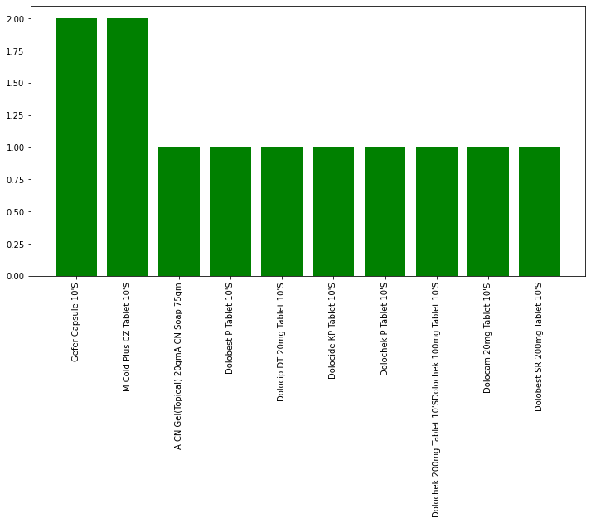

Top 10 reasons for which patients want to visit the hospital or would want to use the app.

Final Product Prototype

Health Care App

The above schematic diagram shows that we provide doctor appointment services by visiting hospitals and clinics. This helps reduce waiting times for patients and connects them with competent doctors for their health issue without manual searching. We charge only 8% of the appointment fee for this service. Secondly, patients can resolve their health issues through video conferencing from their homes, without going to a hospital or clinic in their town or from any big city in India. We charge only 18% of the appointment fee for this service. If a patient has visited a doctor in another city and cannot find the prescribed medicine in their locality, they can order these medicines at discounted prices on our app. We also recommend cheaper medicines of the same composition, which decreases their expenses on medicine. We charge only 5% of the total bill amount for this service. We also provide medical tests like blood tests to be done through home sample collection. For tests like X-ray, MRI, and others that require a diagnostic center, we book appointments and give users the option to select convenient times. Reports for both blood tests and other tests are delivered in hard copy at the patient's home and soft copy on the given email or WhatsApp number. We charge only 12% of the total test bill amount for this service.

Business Modelling

The business model outlined sin this Healthcare Data Analysis App focuses on providing a comprehensive healthcare solution that benefits both patients and healthcare professionals. Here are the key components of the business model:

1. Service Success in Small Towns and Villages: The app has been successful in small towns and villages by enabling people in rural areas to book appointments with doctors in big cities through video conferencing. This service allows patients to pay appointment fees using convenient payment schemes available locally, such as UPI or Aadhaar card payments at Pragya Kendra centers. Additionally, patients can purchase medicines, including rare ones, at discounted prices from wholesalers, saving up to 20-25% compared to MRP.

2. Revenue Generation: The business model involves charging fees for various services provided to patients. For doctor appointments, the app charges a 15% fee for face-to-face visits and an 18% fee for video conferencing appointments. For medicine orders, a 5% fee is charged on the total bill before tax. Moreover, a 15-18% discount is offered on the final bill, providing additional value to patients.

3. Enhanced Accessibility: By offering services that eliminate the need for patients to travel to big cities for healthcare needs, the app saves time and inconvenience. Patients can access treatment, consultations, and medication recommendations at their fingertips, revolutionizing healthcare accessibility in villages and small towns.

4. Patient Data Analysis: The app collects and analyzes various patient data, including age, gender, medical history, symptoms, and more. This data-driven approach enables personalized health advice, treatment plans, and cost-effective recommendations tailored to individual patient needs.

5. Cost Reduction and Efficiency: By facilitating access to proper medical treatment at lower costs, the app aims to reduce financial burdens on patients and improve overall healthcare efficiency. Patients can benefit from affordable healthcare services without compromising on quality or accessibility.

6. Empowering Patients: The business model empowers patients to make informed decisions about their healthcare by providing them with valuable information, cost comparisons, and access to competent doctors and medical facilities. This empowerment leads to better health outcomes and improved quality of life for individuals.

In conclusion, the business model of the healthcare analysis app prioritizes affordability, accessibility, and personalized care for patients while also supporting healthcare professionals in delivering efficient and cost-effective services. By leveraging data science and innovative technology, the app aims to revolutionize the healthcare landscape and enhance the overall patient experience.

Financial Equation

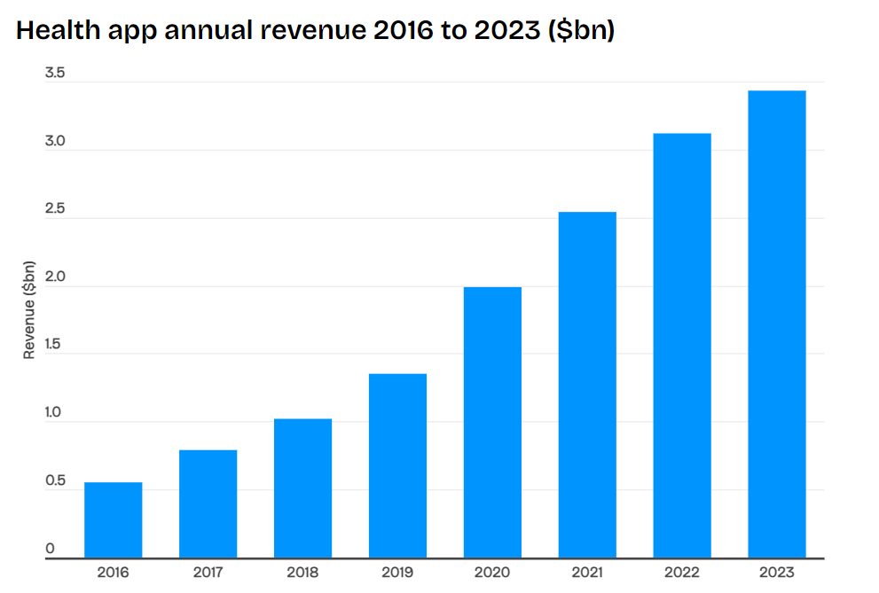

The report here shows that although health care market was always on the rise but the pandemic that hit in the year 2020 makes this market more useful from a business perspective. So, the idea is to make a app that connects the patients with doctors and labs for their treatment and checkups. One aspect of the app is that it can connect with the doctors virtually on a video conference. For this service we have decided to take 8% of doctor’s fee. The financial equation for this feature is.

Suppose a doctor charges 1000 Rs for consultation so for virtual connection we charge 80Rs per patient.

$$y1=80x-c$$

Where y1= profit, c= operating cost per day

Similarly, there are more features that are provided in the application and let’s denote the feature by the number following the alphabet. Now the overall financial equation becomes.

$$total profit\left(y1+y2+y3+y4\right)=\left(T1+T2+T3+T4\right)-c$$

The explanation for the equation- y1,y2,y3,y4 are the profits for 1st 2nd 3rd and 4th feature respectively whereas T1,T2,T3,T4 are the percentage of commission that the app will take from each patient and c is the operating cost per day for the app.

Conclusion

The healthcare analysis app/service for patients represents a transformative tool in the modern healthcare landscape, offering personalized support, data-driven insights, and enhanced connectivity to empower individuals in their pursuit of optimal health and wellness. Through continuous innovation and user-centric design, this platform holds the promise of revolutionizing the way individuals engage with and manage their healthcare, ultimately leading to better health outcomes and improved quality of life.

**Submitted by:**

* Aun Bin Saba
* Aashin Ceaser
* Akash
* Abhinav Mishra